**Experiment No.3 Date:28/09/2021**

**Verification of Kirchhoff’s Voltage Law, Mesh Analysis and Equivalent Resistance**

**Objectives:**

1. To verify KVL and find the mesh currents and nodal voltages.
2. To verify the equivalent resistance of the circuit from different terminals

**Simulation Tool:**

LTSpice – dc operating point analysis and transient analysis.

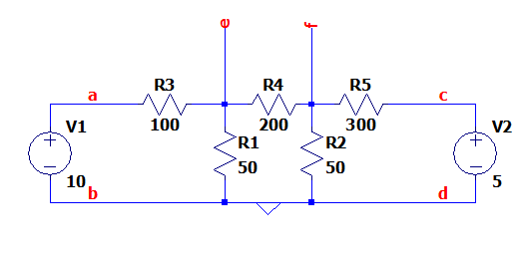**Circuit:**

**Observation:**

**I1 =** 0.06983A

**I2 =** -0.00948A

**I3 =** -0.01293A

|  |  |  |  |  |
| --- | --- | --- | --- | --- |
| **S. No** | **Element/Branch** | **Current (A)** | **Voltage (V)** | **Power (W) Dissipated** |
| **1** | **R1** | 0.06983A | 6.9827 V | 0.488W |
| **2** | **R2** | -0.00948A | -1.8965 V | 0.018W |
| **3** | **R3** | -0.01293A | -3.8790 V | 0.050W |
| **4** | **R4** | 0.06034A | 3.0172 V | 0.182W |
| **5** | **R5** | -0.02241A | 1.1205 V | 0.025W |
| **6** | **V1** | -0.06983A | 10 V | -0.698W |
| **7** | **V2** | -0.01293A | 5 V | -0.064W |

**To Do:**

1. Find the mesh currents **I1, I2 and I3** using the above measurements
2. Verify KVL in the independent loops
3. Compute the equivalent resistance of the circuit from terminals **a-b, c-d, e-f** and understand they are different.
4. Insert the picture of all the theoretical calculation done in your notebook

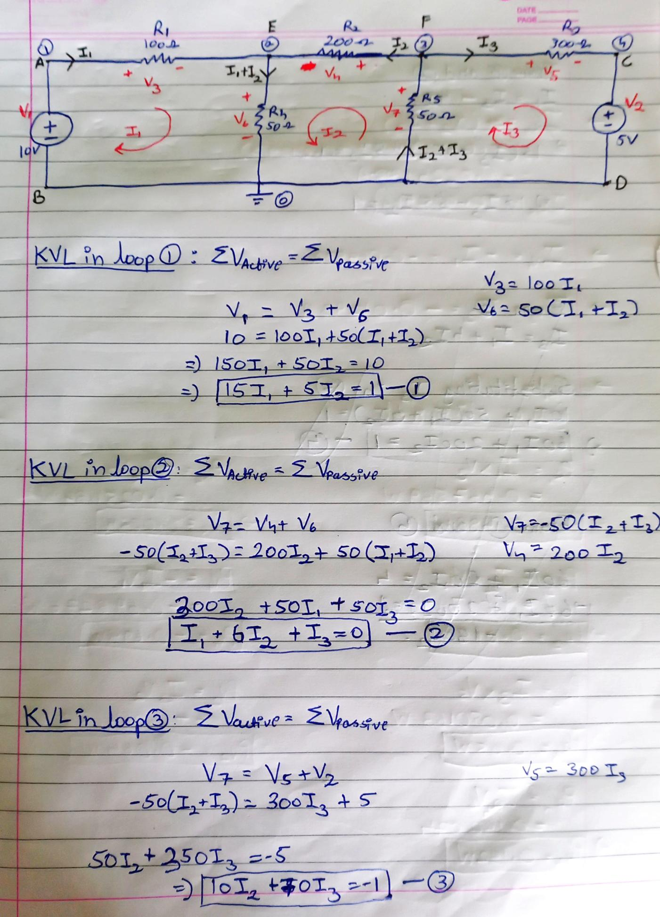 **1. KVL and Mesh Analysis:**

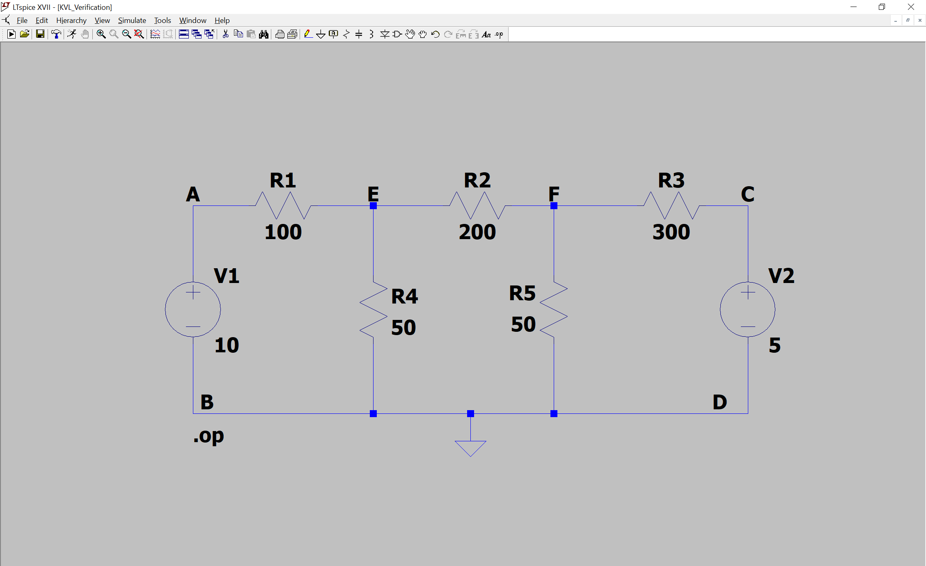



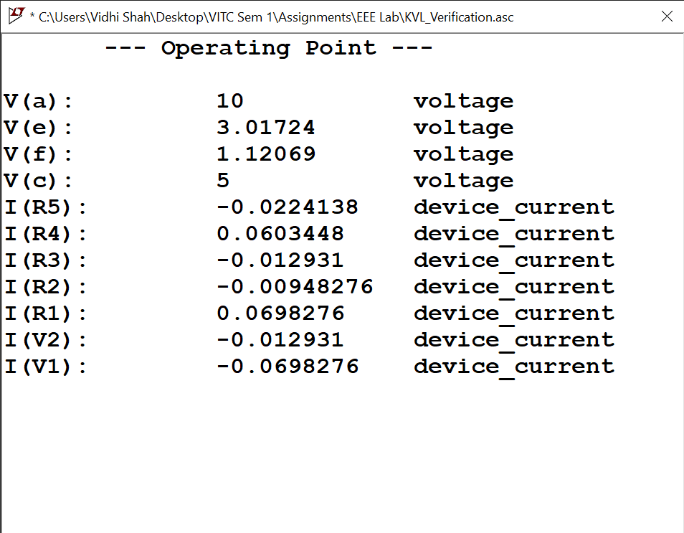

* **Calculations**

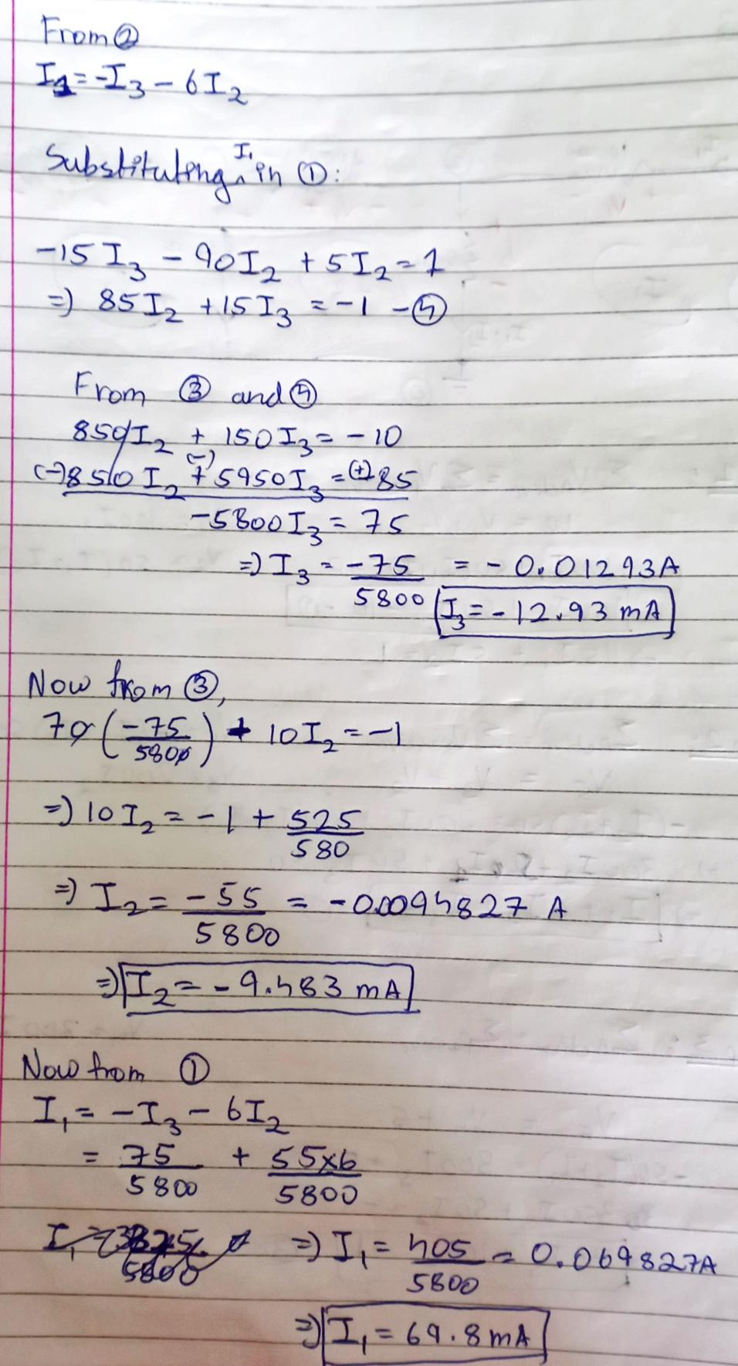

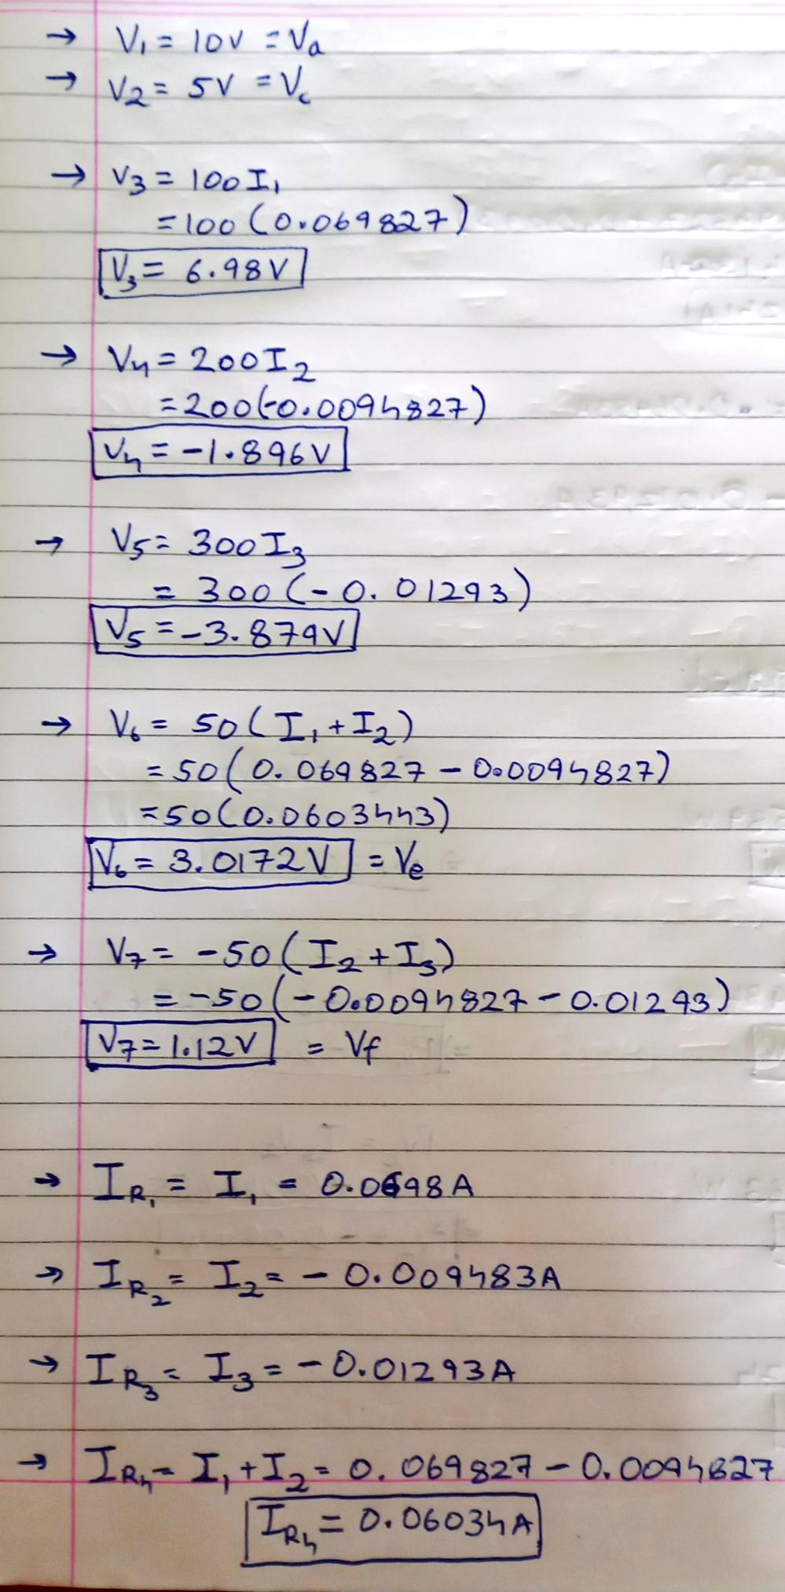



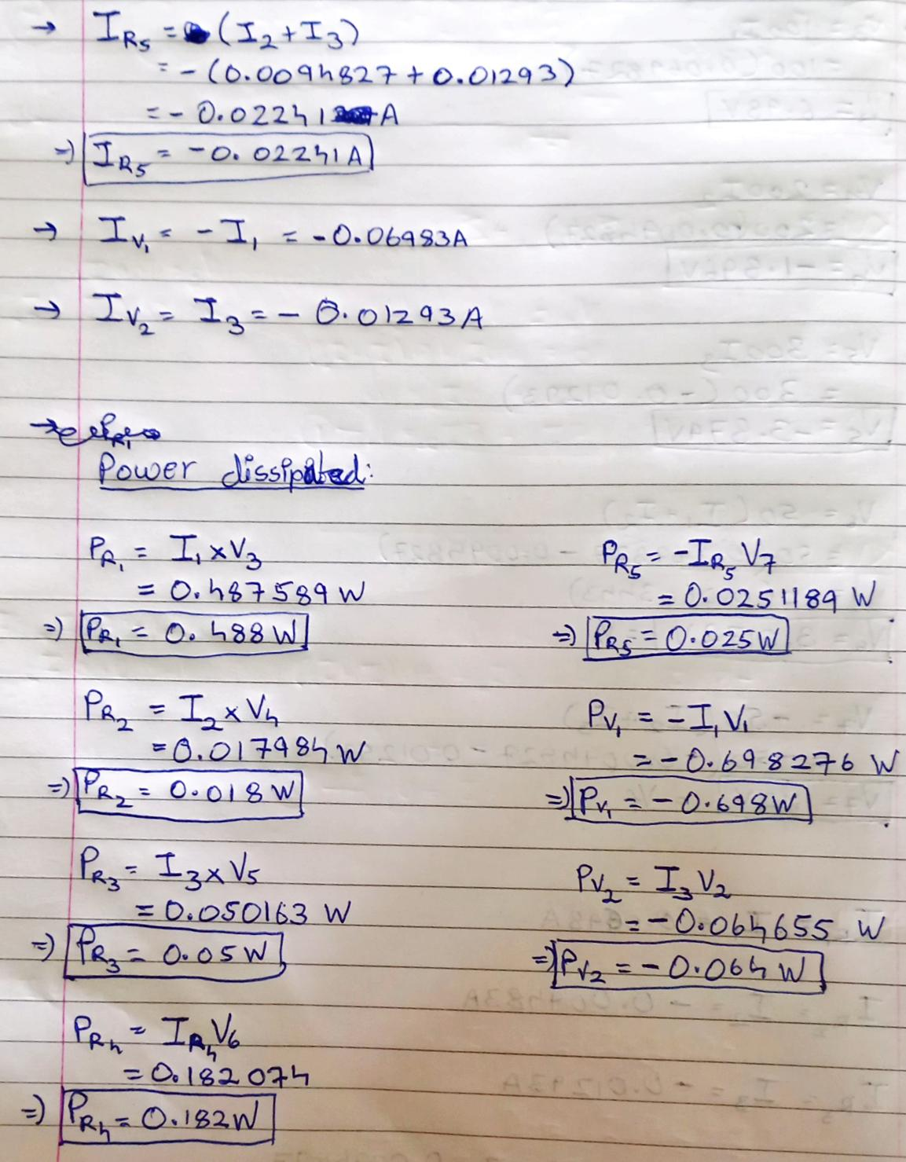

**2. Compute Equivalent Resistance between different nodes**

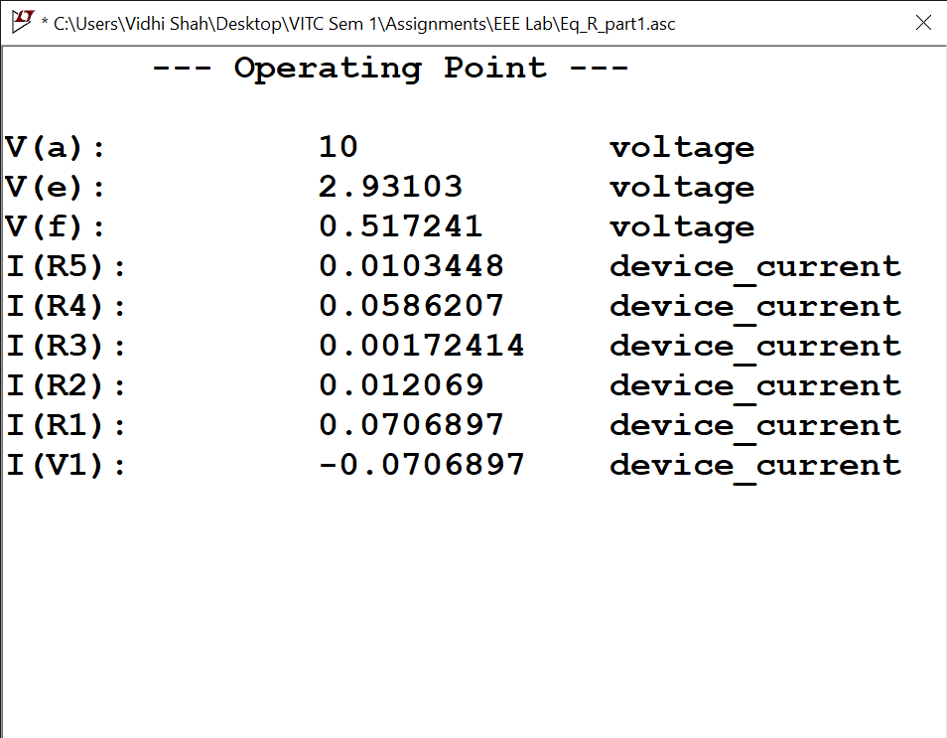**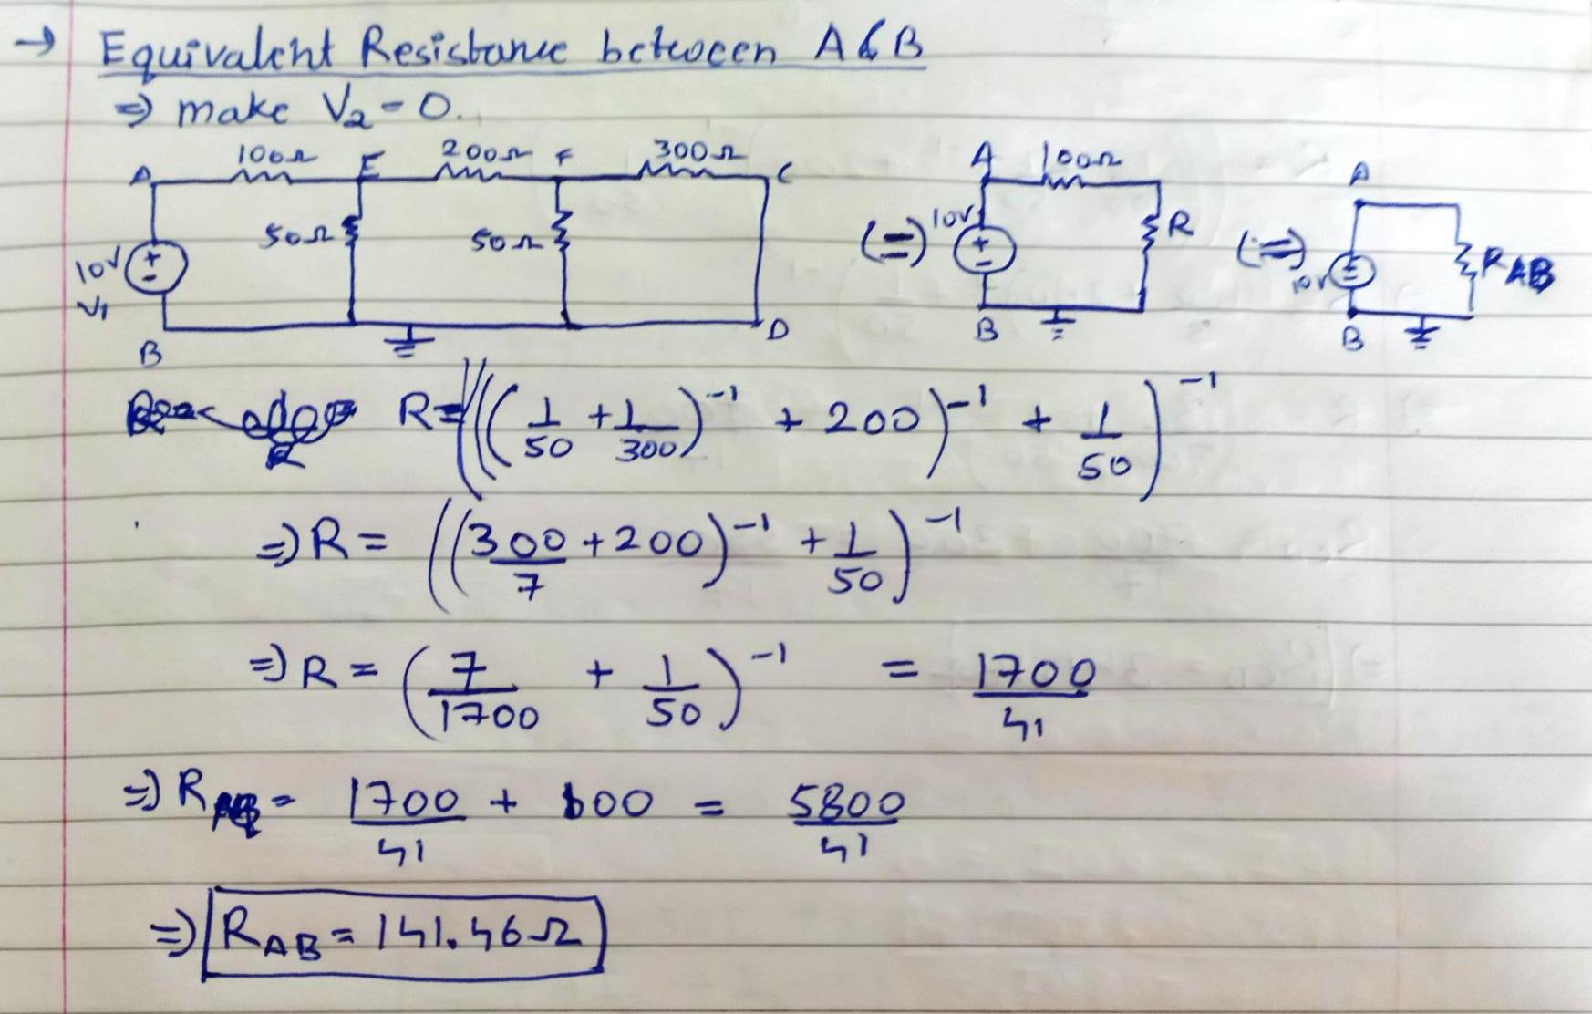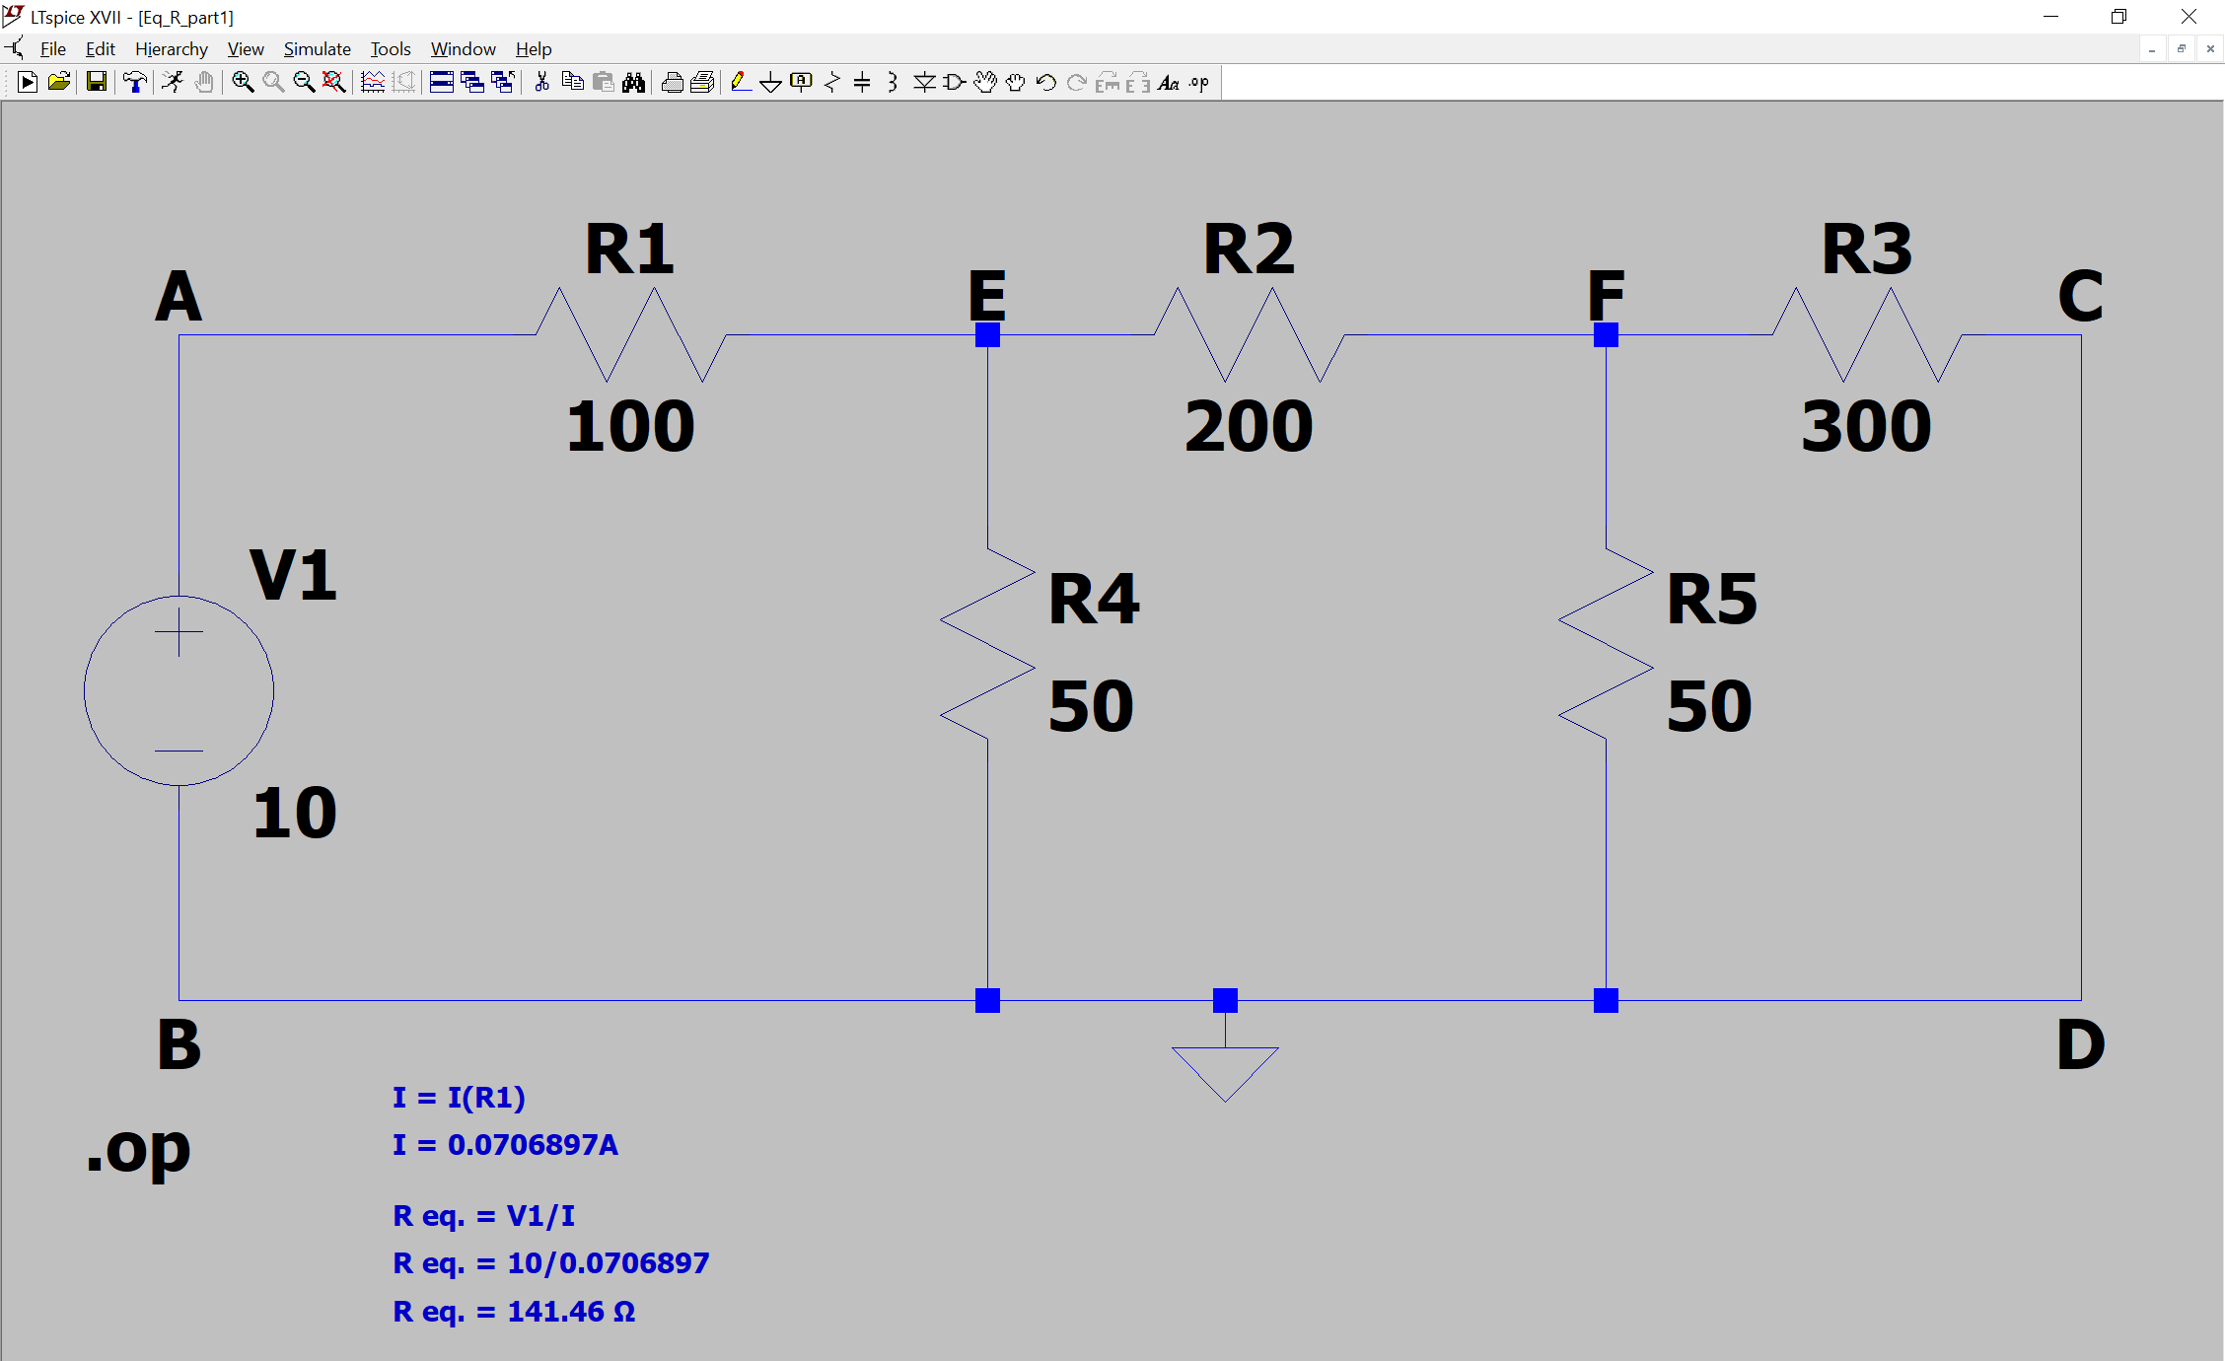a-b**

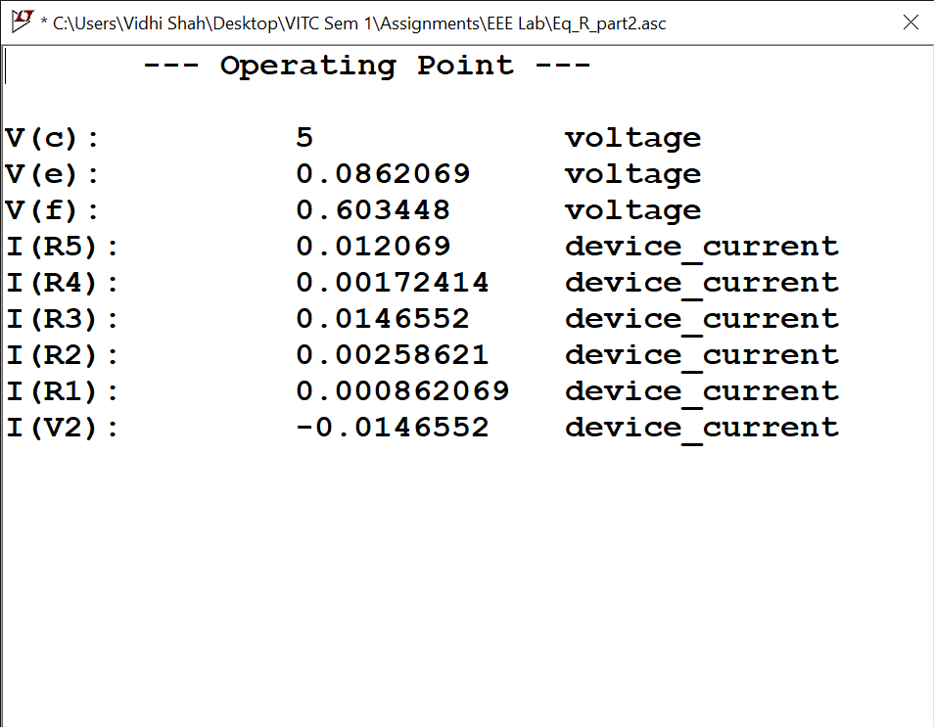**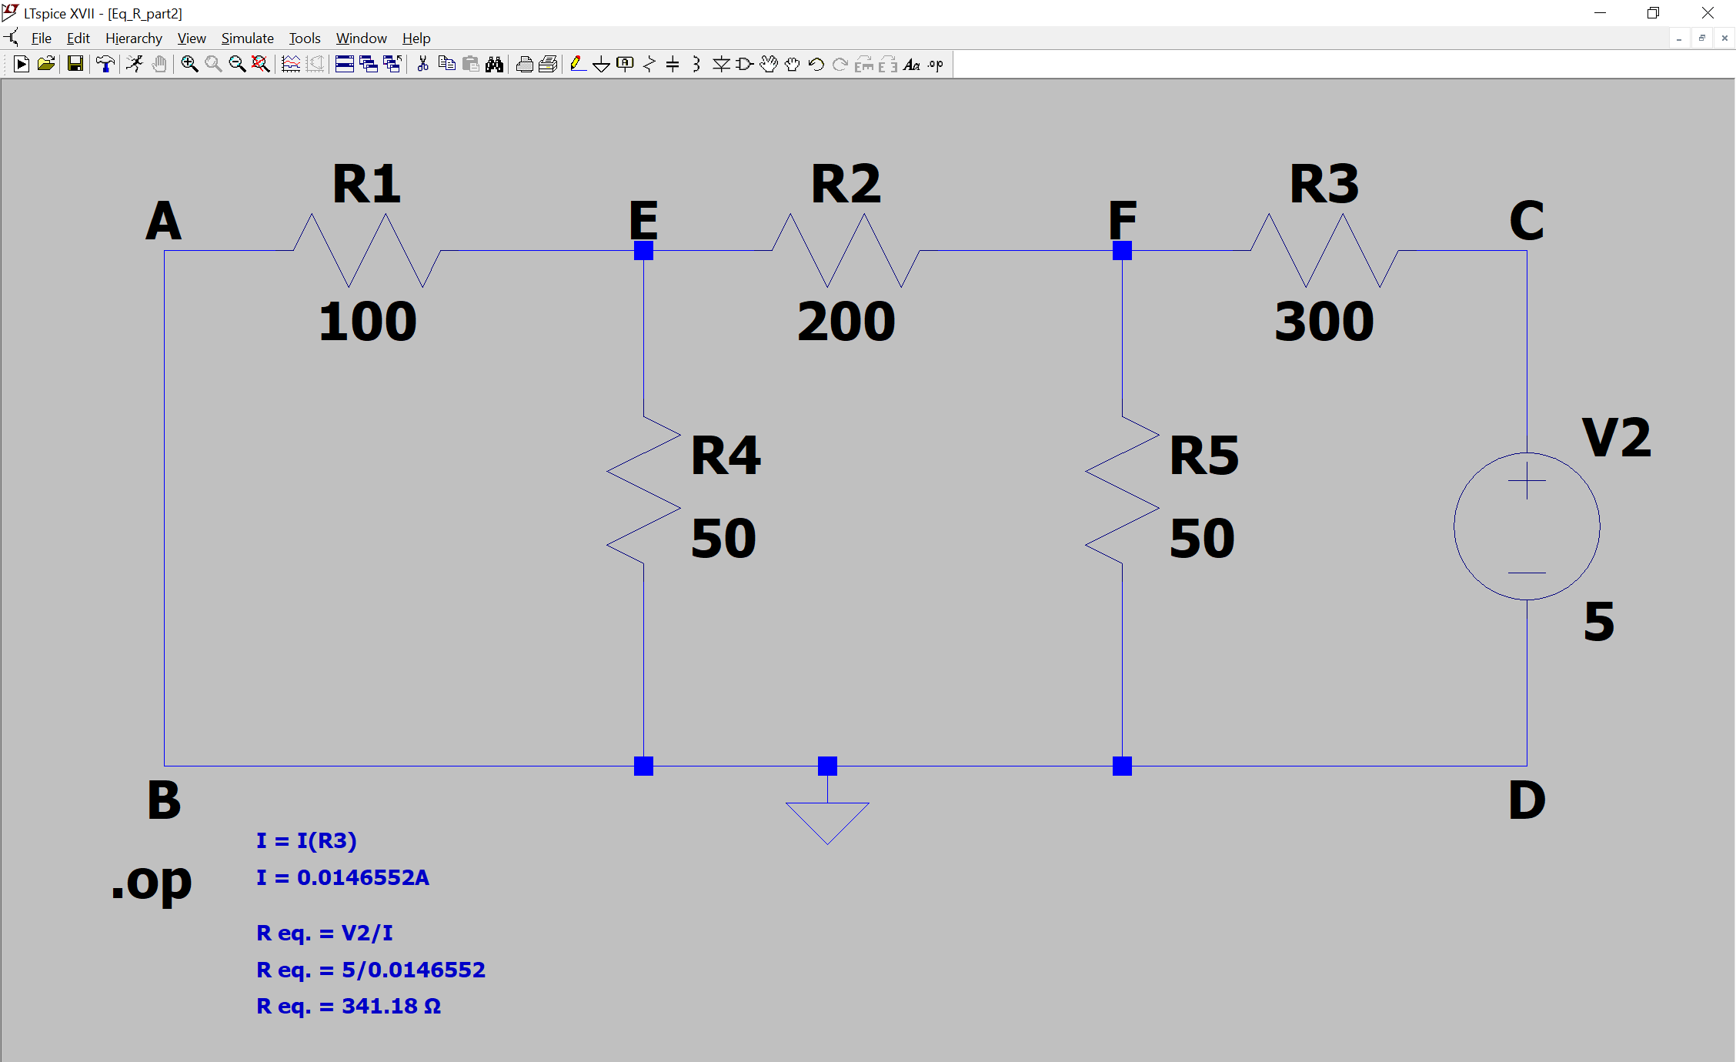c-d**

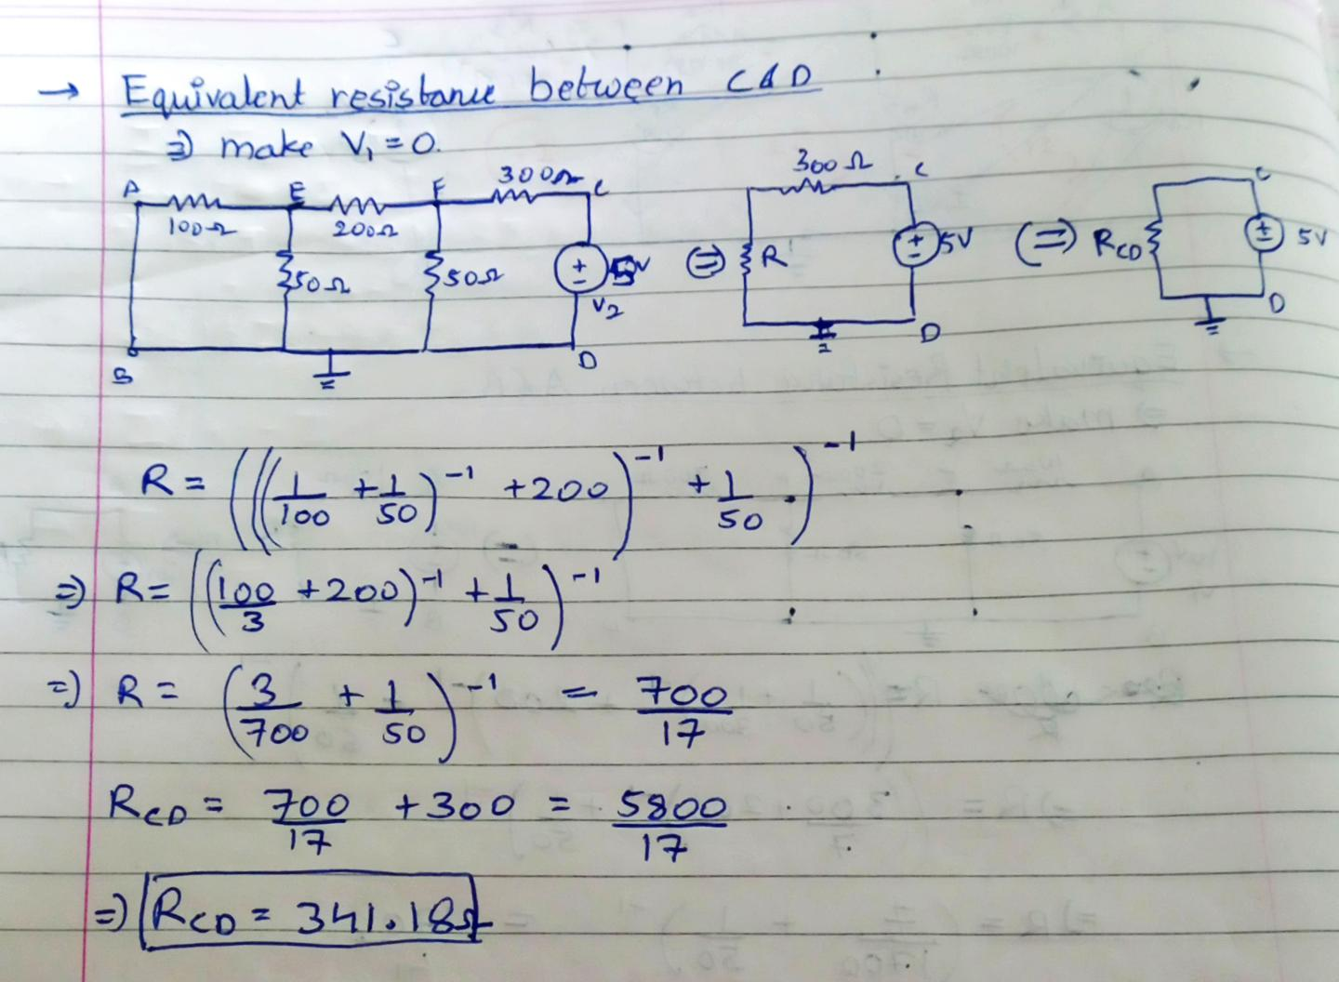

**e-f**

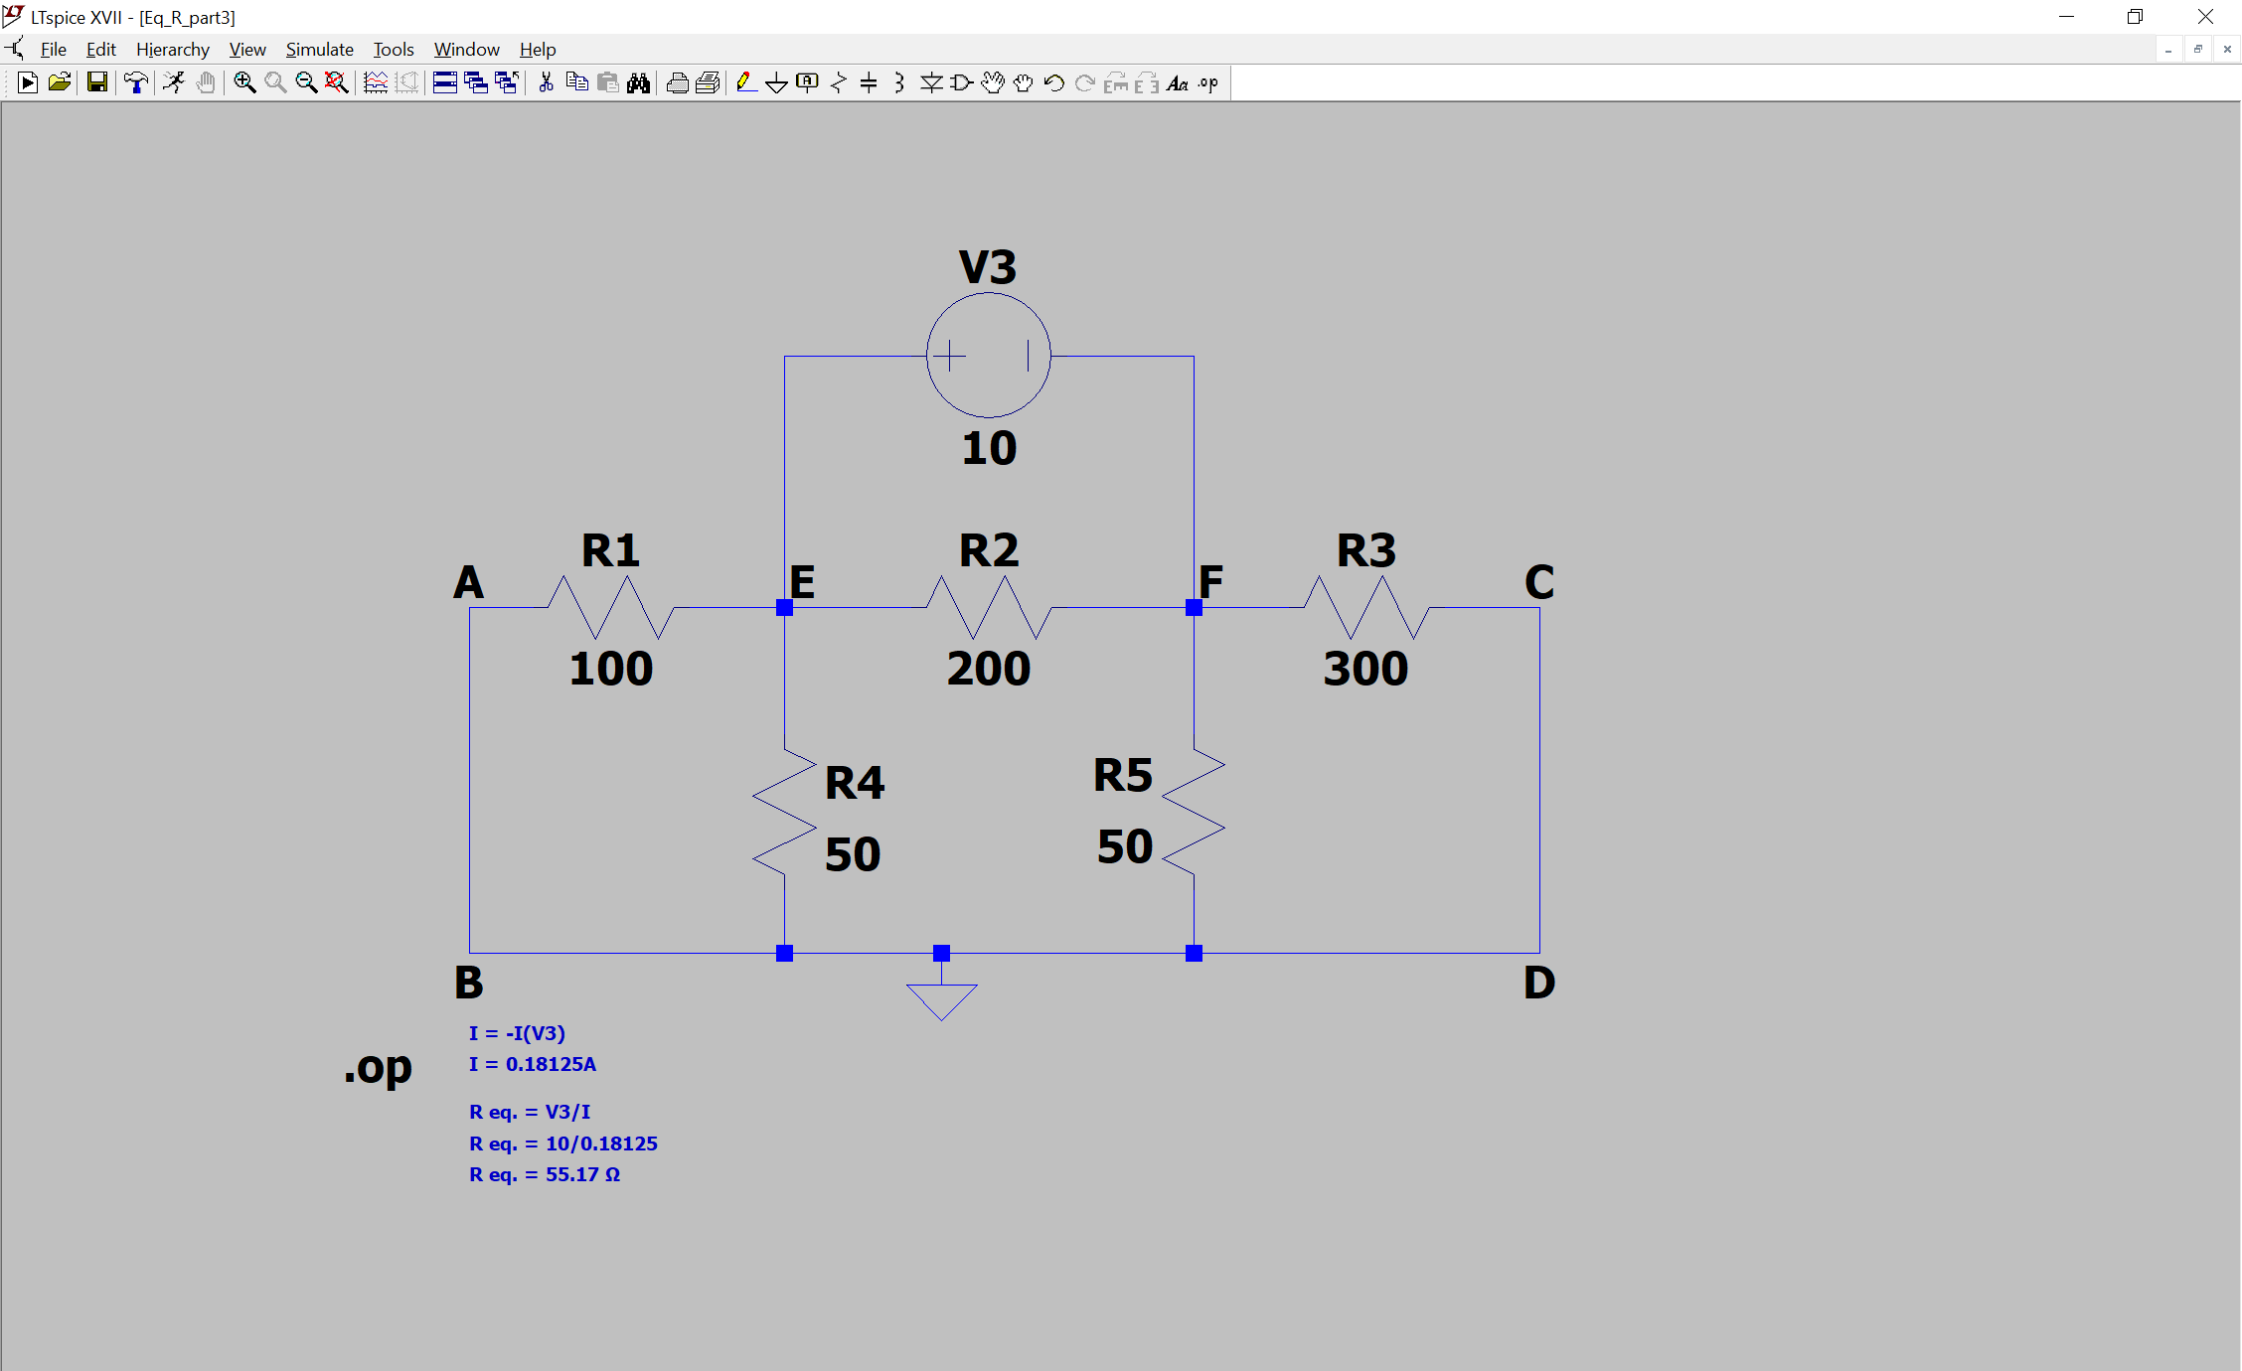

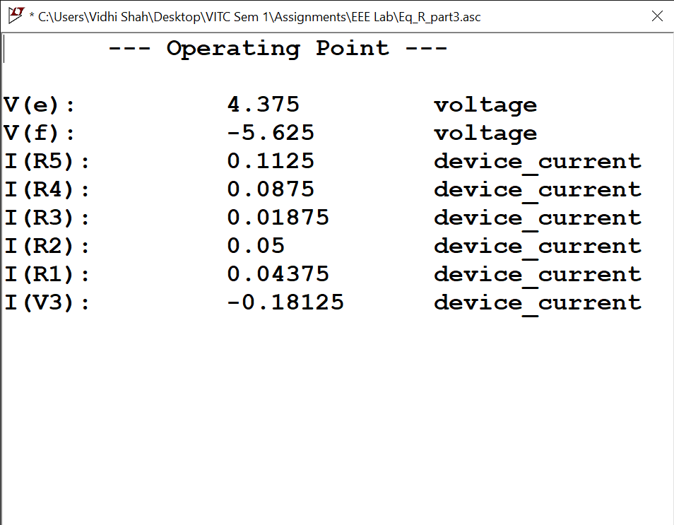

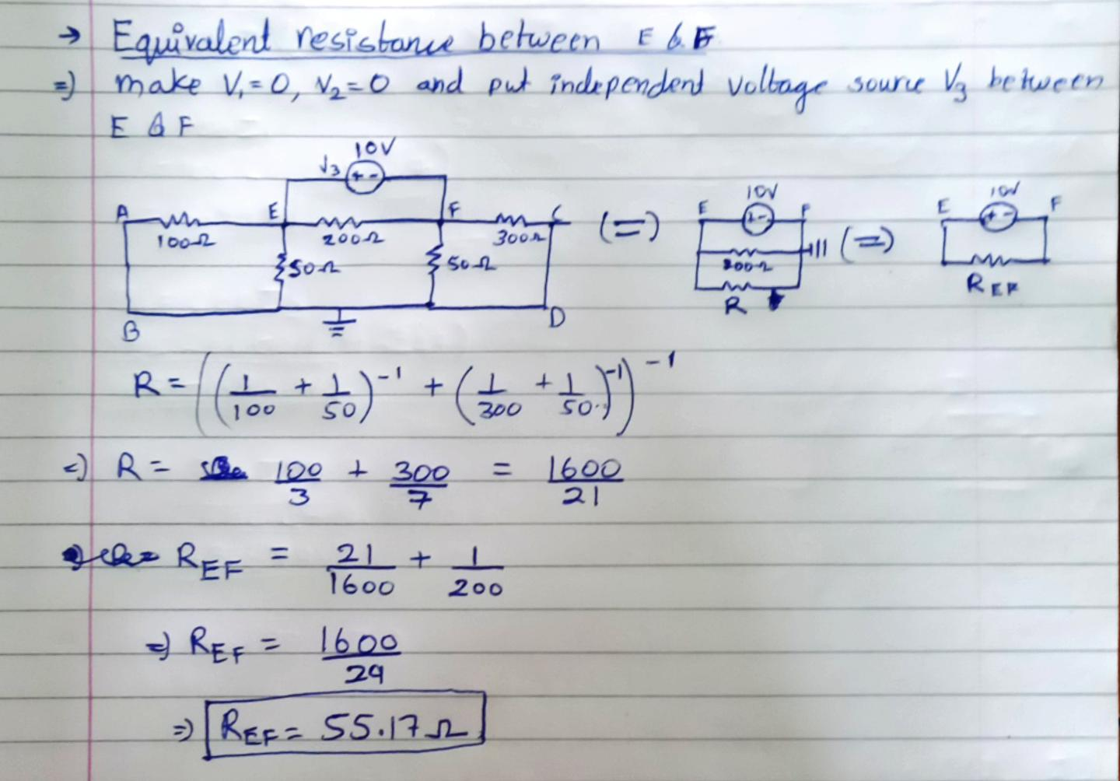

**Do it yourself:**

For the circuit given below, Verify KVL, KCL, Nodal Analysis and Mesh Analysis using LTSpice and TinkerCAD

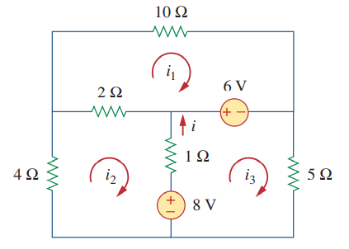

1. 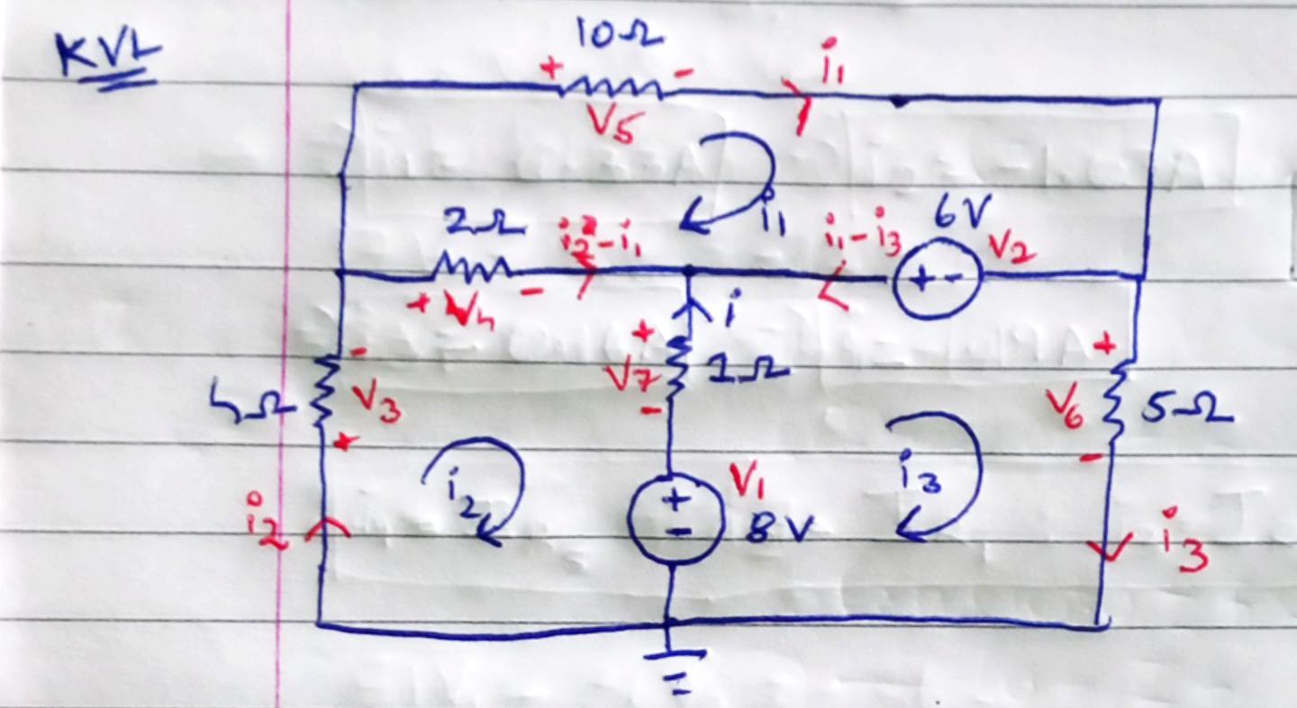**KVL – Mesh Analysis**

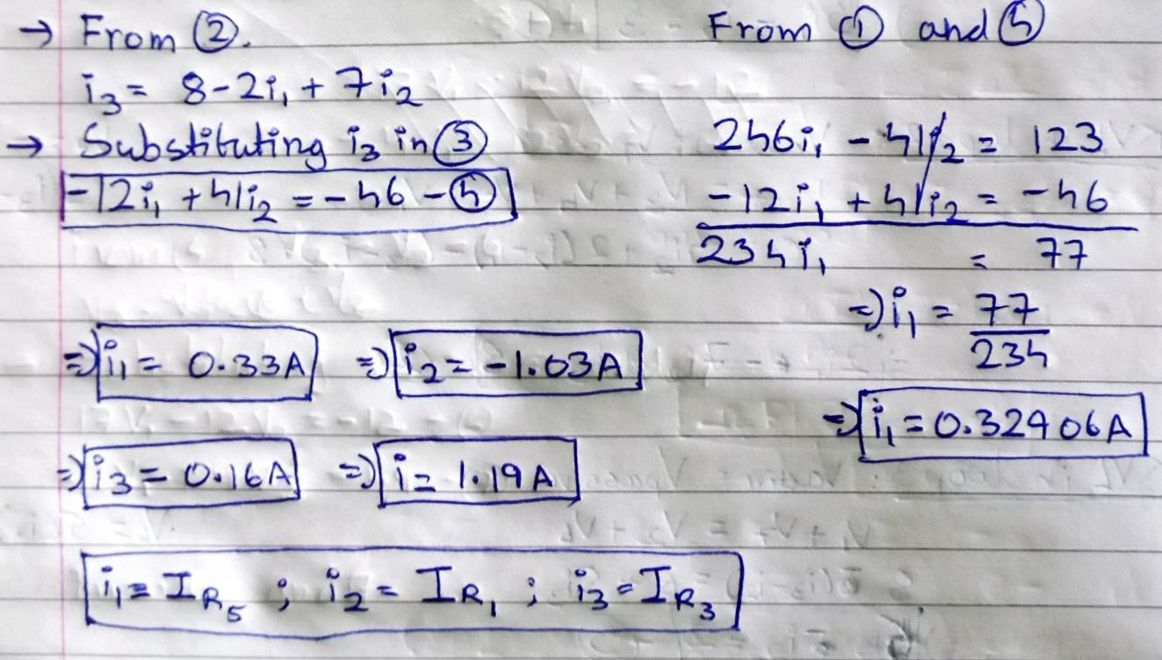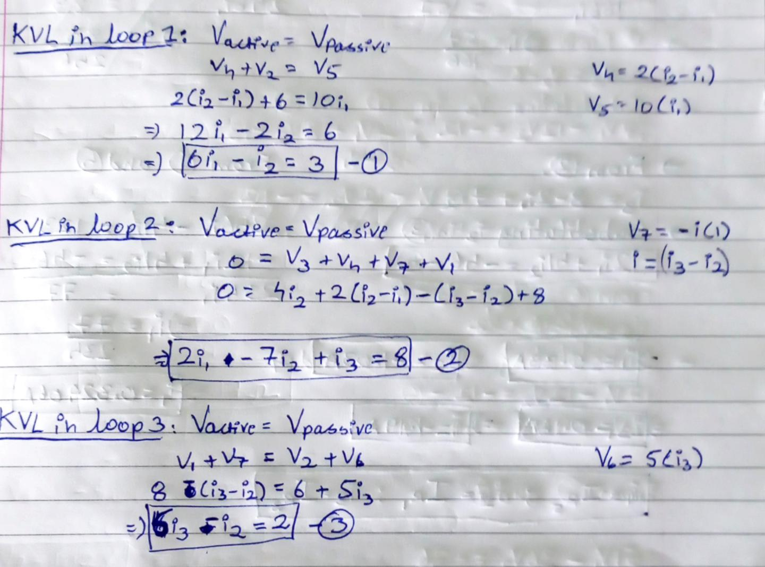

1. **KCL – Nodal Analysis**

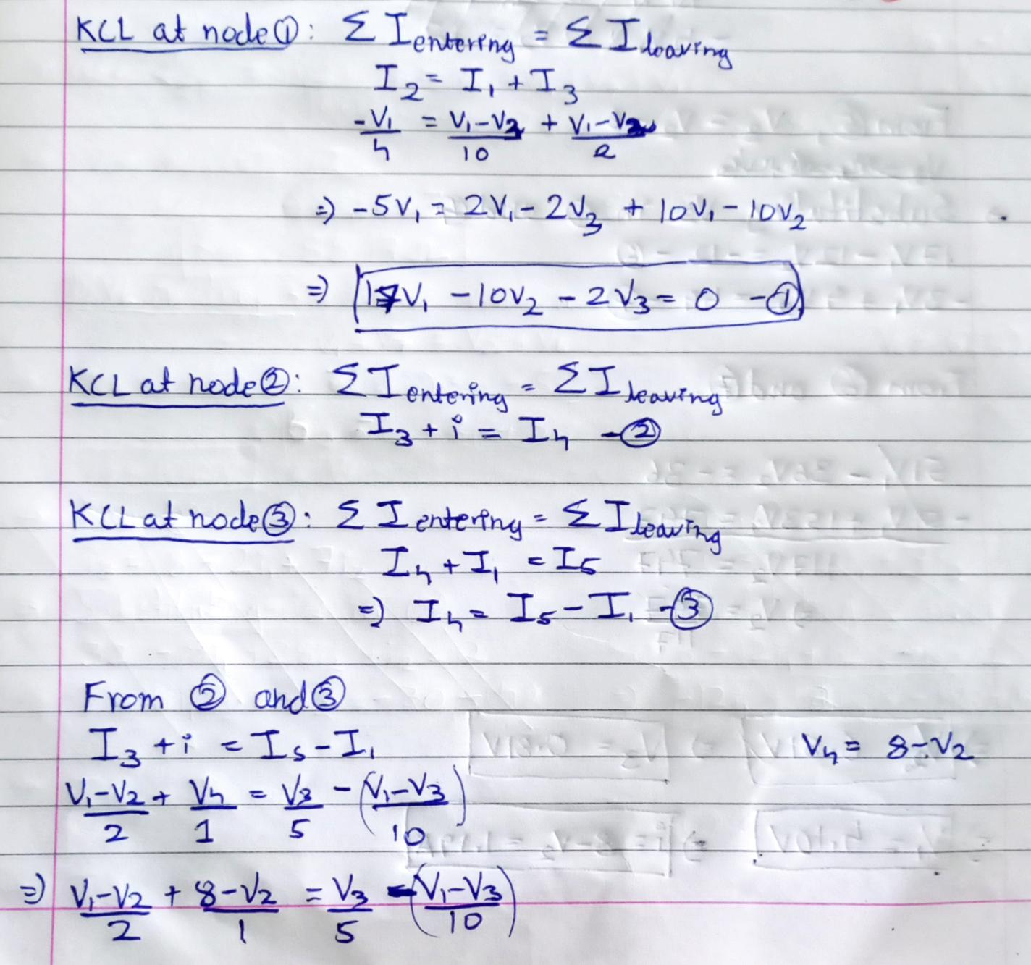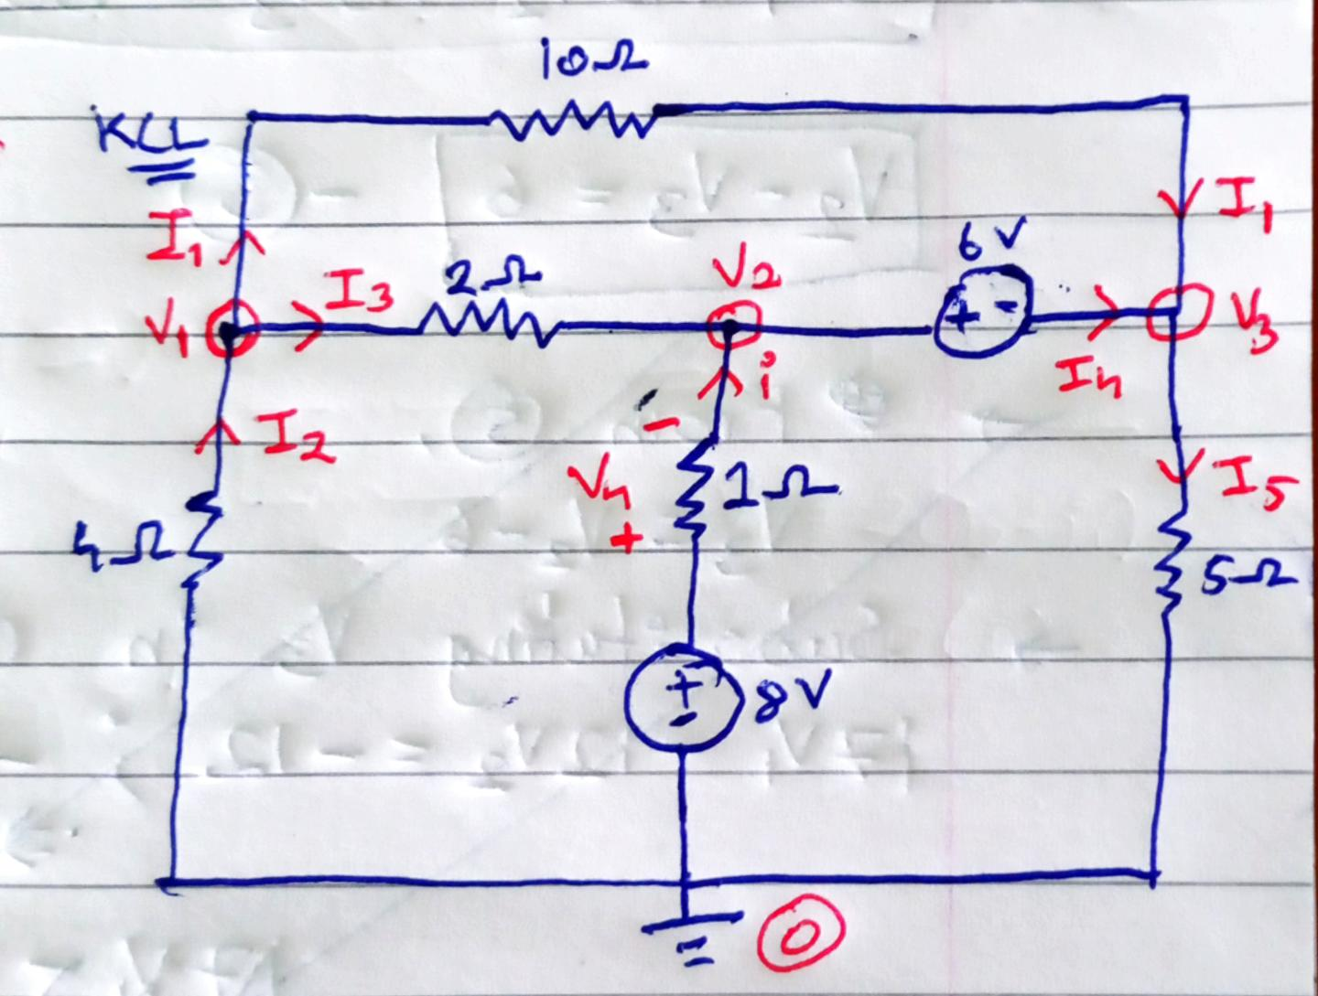

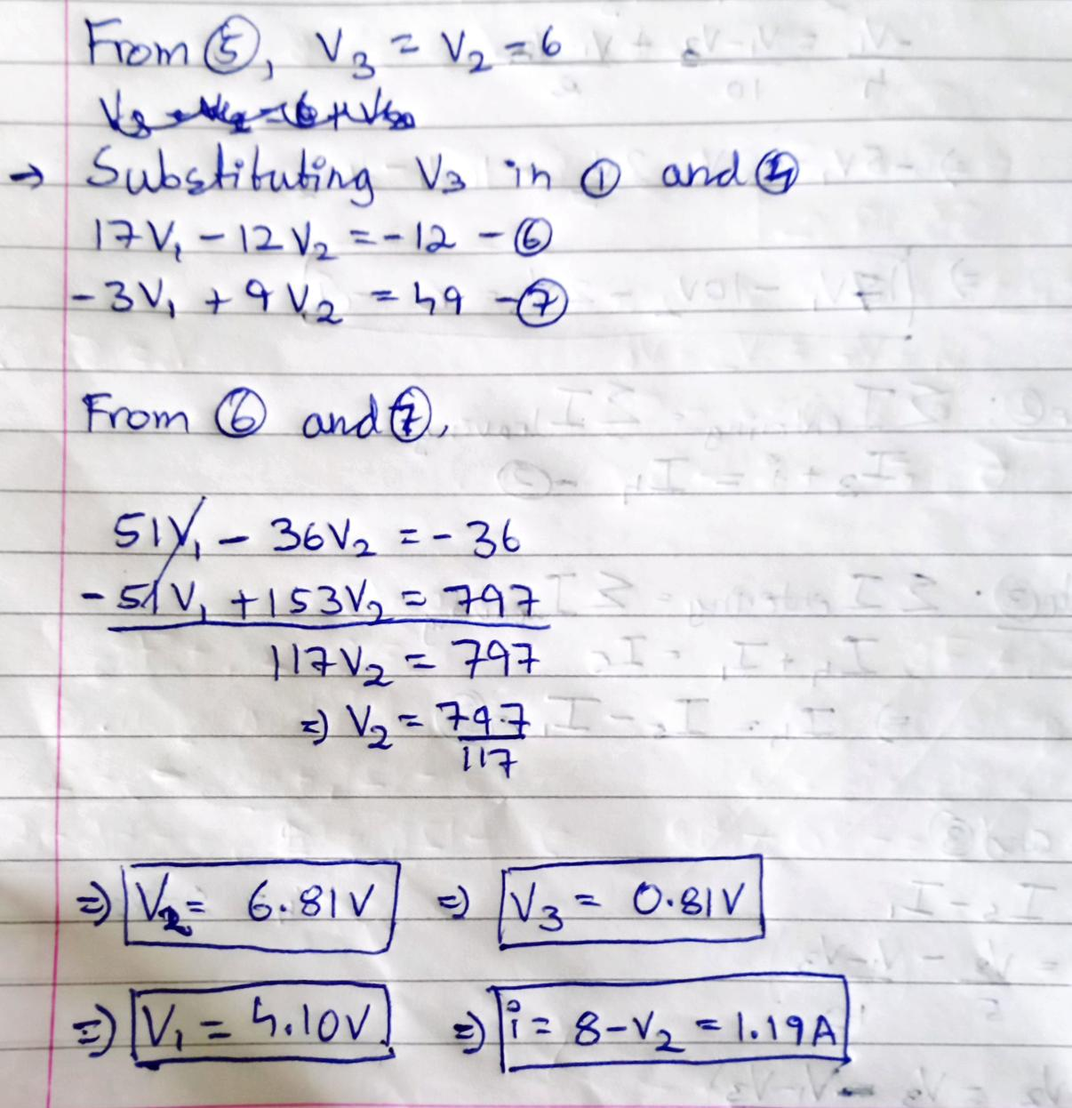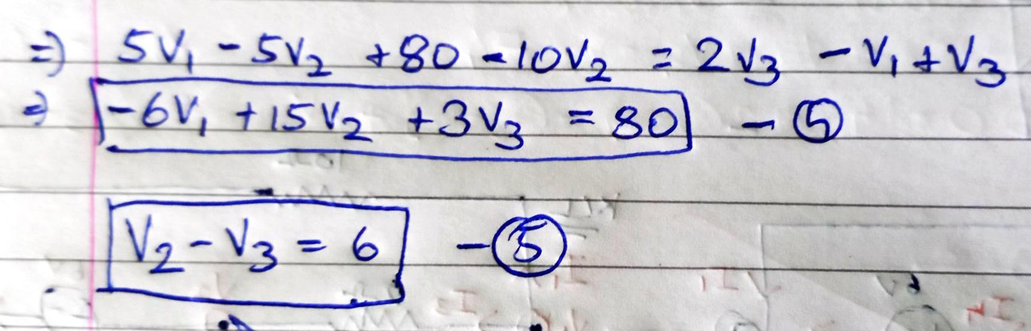

1. **LTSpice**

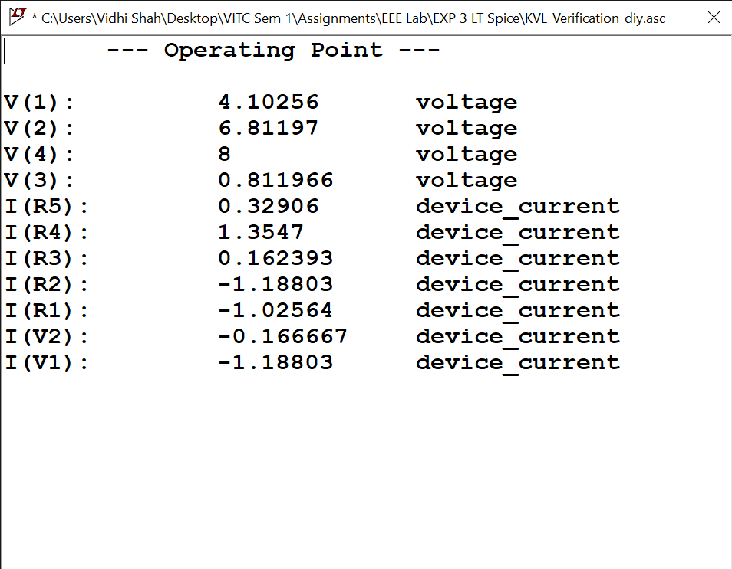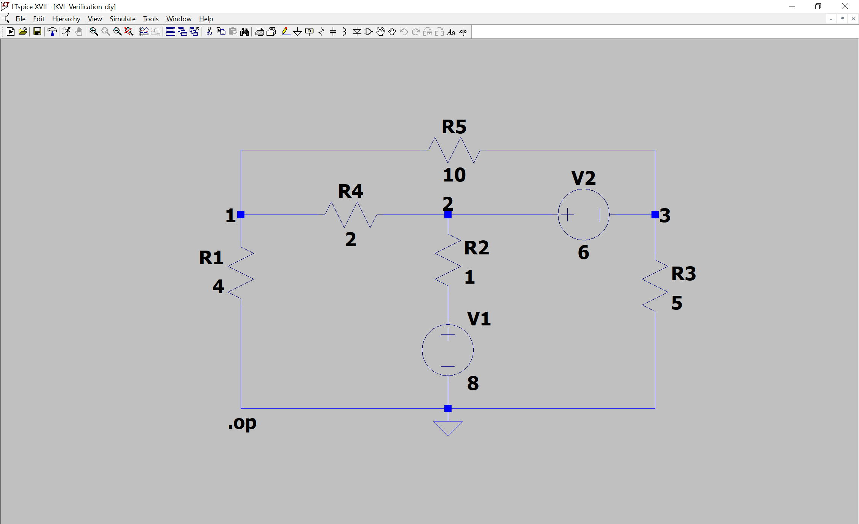

1. **TinkerCAD**

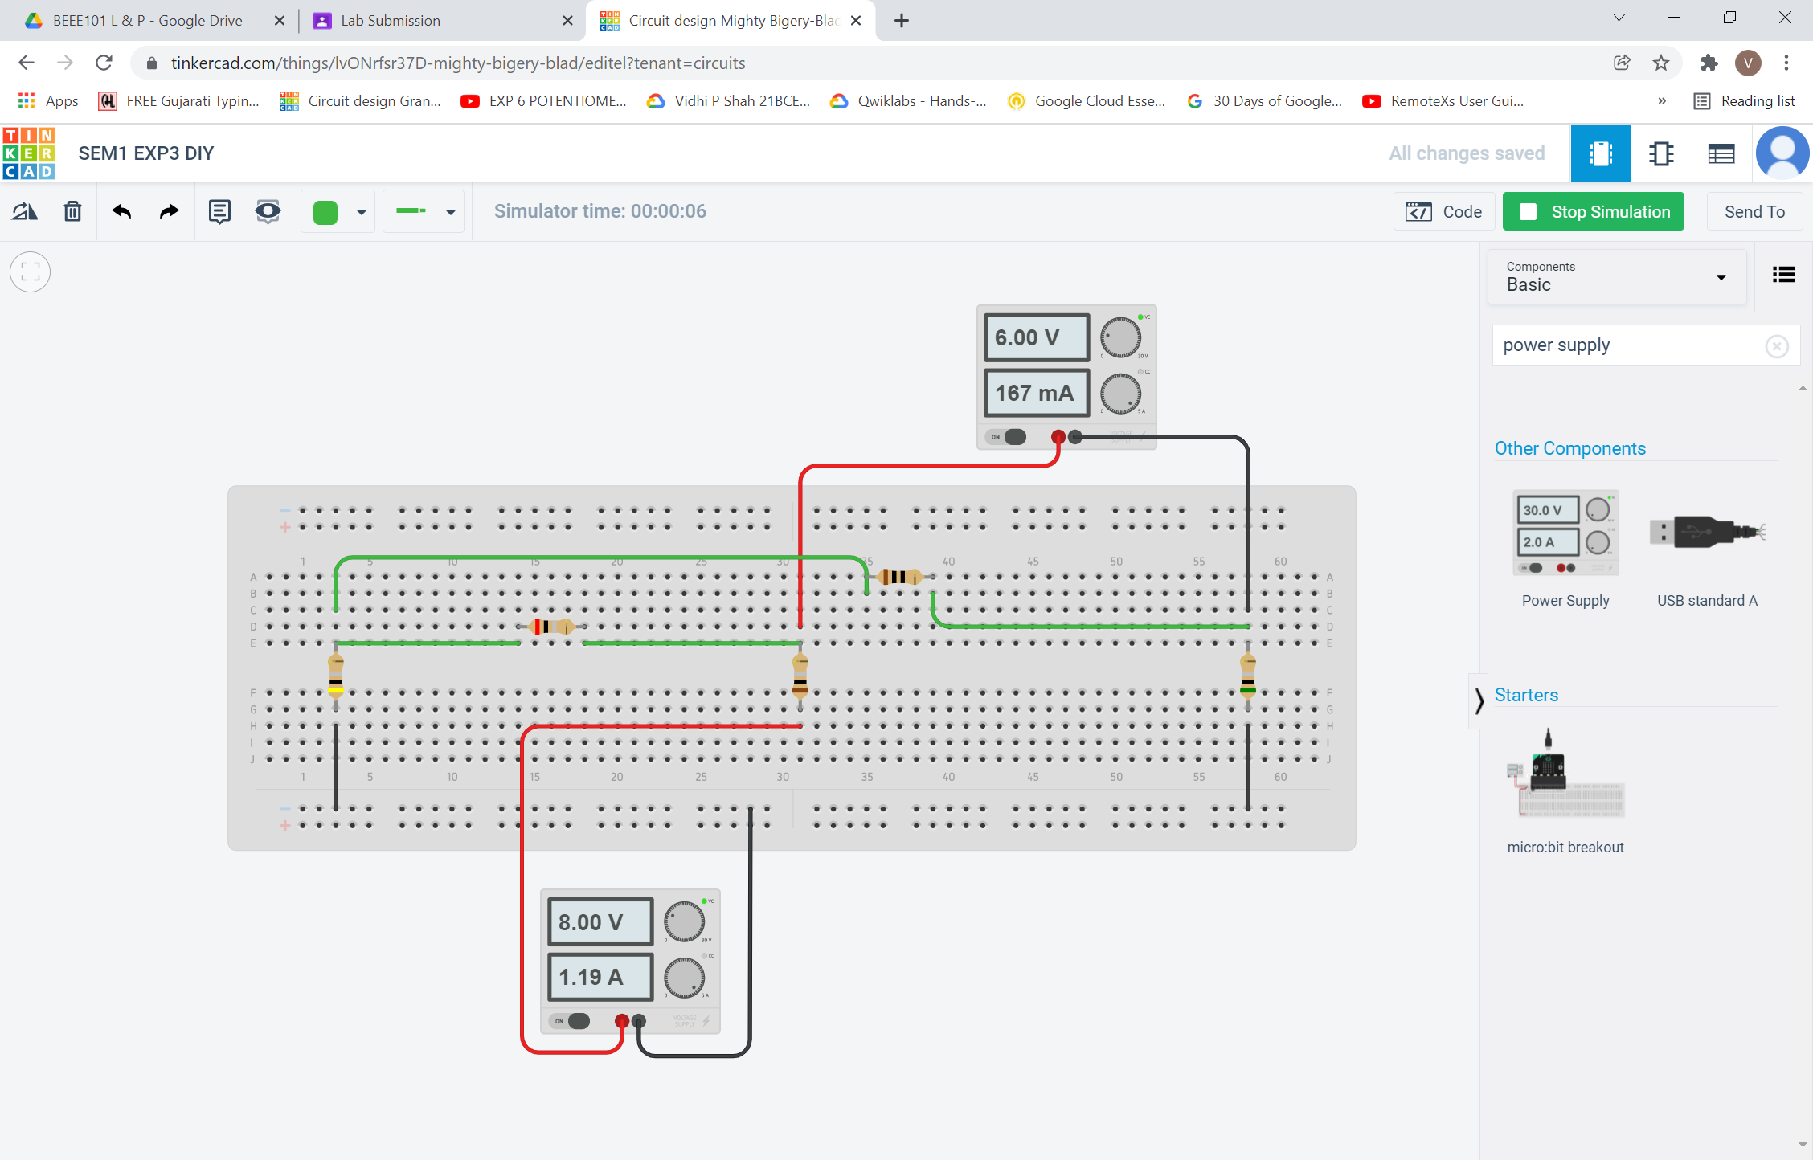

i